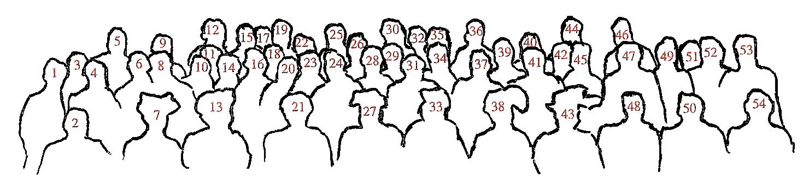

Explanation of a group photo of the participants of the First International Conference on Seismology in Strasbourg 1901. The persons were identified on the original picture. I follow the original German figure caption and added some additional information in parentheses (for numbers see the sketch): 1 Prof. Omori Tokyo, 2 Prof. Wiechert Göttingen, 3 Dr. Schütt Hamburg (Richard Schütt, 1864 – 1943), 4 Prof. Schmidt Stuttgart, 5 Dr. Hecker Potsdam, 6 Prof. Rudolph Strassburg, 7 Prof. Gerland Strassburg, 8 Prof. Weigand Strassburg (Bruno Weigand), 9 Prof. Oddone Pavia, 10 General Pomerantzeff St. Petersburg (B. J. Pomerantzeff), 11 Staatsrat Lewitzky Jurjew-(Dopart), 12 Prof. Günther München (Siegmund Günther 1848 – 1923), 13 Geh.-Rat Wagner Göttingen (Hermann Wagner 1840 – 1929), 14 Geh.-Rat Helmert Potsdam, 15 Prof. Straubel Jena (Rudolf Constantin Straubel 1864 – 1943), 16 Assist. Ebell Strassburg ([Carl Wilhelm Ludwig] Martin Ebell 1871 – 19??), 17 Oberstleutnant Harboe Kopenhagen (Edouard Georg Harboe 1845 – 1919), 18 Dr. Tetens Strassburg (Otto Peter Harens Tetens 1865 – 1945), 19 Prof. Láska Lemberg (Václav [also Waclaw] Láska 1862 – 1943), 20 Prof. Futterer Karlsruhe (Franz Joseph Xaver Futterer 1866 – 1906), 22 Prof. v. Kövesligethy Budapest, 22 Dr. Polis Aachen (Peter Hermann Johann Polis 1869 – 1929), 23 Dr. Schafarzik Budapest (Ferencz [also Franz] Xav. Schafarzik 1854 – 1924), 24 Prof. Leutz Karlsruhe (Heinrich Leutz), 25 Bauinspektor Jähnike Strassburg (A. Jähnike), 26 Prof. Kobold Strassburg (Hermann Kobold 1858 – 1942), 27 Dir. Wosnessensky Jrkutsk (A. W. Wosnessensky), 28 Geh.-Rat Lewald Berlin (Theodor Lewald 1860 – 1947), 29 Dr. Ehrismann Strassburg (Henri Ehrismann), 30 Prof. Forel Morges, 31 Prof. Belar Laibach (Albin Belar 1864 – 1939) (from Schweitzer, 2003).

